

**MINI – PROJECT REPORT ON**

**“SIGN LANGUAGE TRANSLATOR”**

**BY**

|  |  |  |
| --- | --- | --- |
| **GROUP MEMBERS** | **SEAT NOS** | **ROLL NOS** |
| **ANUSK KUMAR** | **MITU19BTCS0006** | **2193049** |
| **APURV KUMAR** | **MITU19BTCS0007** | **2193052** |

**Under the guidance of**

**Prof. Namrata Naikwade**

**DEPARTMENT OF COMPUTER SCIENCE AND ENGINEERING**

**MIIT SCHOOL OF ENGINEERING**

**Loni Kalbhor, Pune**

**M.I.T SCHOOL OF ENGINEERING**

DEPARTMENT OF COMPUTER ENGINEERING

LONI-KALBHOR PUNE

**CERTIFICATE**



This is to certify that the Mini – Project report entitled

“Sign language translator”

Submitted by

|  |  |  |
| --- | --- | --- |
| **GROUP MEMBERS** | **SEAT NOS** | **ROLL NOS** |
| **ANUSK KUMAR** | **MITU19BTCS0006** | **2193049** |
| **APURV KUMAR** | **MITU19BTCS0007** | **2193052** |

is a record of Bonafide work carried out by them, under my guidance, in partial fulfillment of the requirement for the second year of Computer science Engineering at M.I.T School of Engineering, Pune under MIT Art, Design & Technology University.

Date: Place:

***Prof. Reena Pagare Dr. Rajneesh Kaur Sachdeo***

**Guide, Dean Engineering**

**Department of CSE Head, Department of CSE**

**M.I.T School of Engineering M.I.T School of Engineering**

**Loni Kalbhor, Pune Loni Kalbhor, Pune**

**Acknowledgement**

We would like to express our humble gratitude towards our mentor Prof. Namrata Naikwade as well as our principal Dr. Kishore Ravande who gave us this golden opportunity to work on this interesting project - “Sign Language Translator”. This project helped us gain knowledge in Computer Vision and Machine learning which one of the most important fields for research and growth. We were able to create an application which can help deaf people to communicate using sign language as a method of communication. I would also like to acknowledge my parents and friends who supported me to complete this project by providing their hand image in sign language for training CNN model Which helped to increase accuracy of our model for better results. Each member contributed meticulously to complete this project.

Once again, I would like to thank each and every person who made this project successful.

**Group Members:**

Anusk Kumar

Apurv Kumar

**TABLE OF CONTENTS**

|  |  |  |
| --- | --- | --- |
| **SR NO.** | **CONTENTS** | **PAGE NO.** |
| **1** | **ABSTRACT** |  |
| **2** | **LIST OF TABLES** |  |
| **3** | **LIST OF FIGURES** |  |
| **4** | 1. **INTRODUCTION** 2. **PROBLEM DEFINITION** 3. **FEATURES OF PROJECT** 4. **PLATFORM/TECHNOLOGY** 5. **FLOWCHART** 6. **OUTPUT** 7. **CODE** 8. **CONCLUSION AND FUTURE ENHANCEMENTS** |  |
| **5** | **GLOSSARY** |  |
| **6** | **REFERENCES AND BIBLIOGRAPHY** |  |
| **7** | **ANNEXURE A** |  |
| **8** | **ANNEXURE B** |  |

**ABSTRACT**

Sign Language Translator is a project which helps deaf and dumb to talk using sign language and then translating it into text.

This project has three stages mentioned below

1) Data set generation: Using this program we capture images to create dataset which will be used in the next stage to train our CNN model for predicting sign language. We need to create dataset just once we can further add more data when we need

2) Training Model: Using this program we create a CNN model then we train it using dataset which we created in the previous program we only need to train model once for using it, we do not need to train it every time we are using translator to translate sign language.

3) Translate sign language: This is the program which we need to run to use translator we need to install few dependencies before we can use translator and a trained model to predict sign language shown by user.

We do not need all three programs every time we want to translate sign language, we just need actual translator only rest of the programs are just used when we want to add more data and further train our model to recognize sign language.

This project was made to help deaf and dumb people to talk normally without any obstructions and present their views.

**LIST OF TABLES**

**LIST OF FIGURES**

**INTRODUCTION**

This project is based on Computer Vision and Machine Learning, where we create dataset and train a CNN model using TensorFlow and Keras and use that trained model to predict sign language shown by user.

As mentioned earlier this project consists of Three programs but only one program is actually required to translate sign languages. rest of the programs are used to create dataset and train model which is required to be done only once.

This project is based on ASL (American Sign Language) and can translate all 26 letters of English and a sign for ‘space’ between letter which is not official but introduced by us.

We have created and trained such a model that you don’t need to train a model from beginning to add additional data we can simply add data and run the program to train model and training will start from where it left last time hence saving time and effort.

This project has a lot of room for improvement and can be modified in such way that it is deployable to mobile phones or any portable device which can be used to translate sign language on the way and we can also add support for different types of sign language such as Indian sign language, etc.

**PROBLEM STATEMENT**

Create three programs given below

1) A program to create dataset for training CNN model for predicting sign language shown by user.

2) A program to create a CNN model and train it using the dataset created with the help of previous program.

3) A program with a GUI to translate Sign Language into text using the concept of computer vision and machine learning.

**FEATURES OF PROJECT**

This project has three programs therefore features of each program with their name is as follows:

1) **GetData_BW.py:** This program reads input from external or internal webcam of device and when we press ‘spacebar’ key it captures image in region of interest.

* It has two trackbars which can be used to determine which letter’s image we are capturing and directory to save it.
* It also shows how many images of given letter are there in their respective directory.
* It also shows the actual image we are saving since we are not saving RGB image directly.

2) **Train_Model.py:** This program is used to create a CNN model using TensorFlow and Keras and then we use dataset generated from previous program to train it.

* It also shows size and actual image which it uses as a data to train model.
* It also plots a graph to show accuracy of model and losses.
* It also predicts few sign languages from ‘test’ type of data to demonstrate its accuracy without actually running translator itself.

3) **Translator.py:** This program is used to actually predict sign language shown by user it has a simple GUI which makes it easier to use

* It has sections which shows letter it is currently predicting, words and message it has formed.
* It has three buttons
  + **Pause:** To pause predicting letters.
  + **Info:** To display information about the project.
  + **Clear:** To Clear message and word section for creating new message.

**PLATFORM / TECHNOLOGY USED IN PROJECT**

1) **PYTHON (3.8.5):**



The object-oriented programming language is commonly used to streamline large complex data sets. ... Being fast, Python jibes well with data analysis. And that's due to heavy support; availability of a whole slew of open-source libraries for different purposes, including but not limited to scientific computing. Python's immanent readability and lucidity has made it relatively easy to use, and the number of dedicated analytical libraries on it can be utilized easily when creating models in dealing with Data Science.

2) **OpenCV:**



OpenCV (Open-Source Computer Vision Library) is an open-source computer vision and machine learning software library. OpenCV was built to provide a common infrastructure for computer vision applications and to accelerate the use of machine perception in the commercial products. Being a BSD-licensed product, OpenCV makes it easy for businesses to utilize and modify the code.

The library has more than 2500 optimized algorithms, which includes a comprehensive set of both classic and state-of-the-art computer vision and machine learning algorithms. These algorithms can be used to detect and recognize faces, identify objects, classify human actions in videos, track camera movements, track moving objects, extract 3D models of objects, produce 3D point clouds from stereo cameras, stitch images together to produce a high resolution image of an entire scene, find similar images from an image database, remove red eyes from images taken using flash, follow eye movements, recognize scenery and establish markers to overlay it with augmented reality, etc.

3) **TensorFlow 2.4:**



**TensorFlow** is a free and open-source software library for machine learning. It can be used across a range of tasks but has a particular focus on training and inference of deep neural networks.

TensorFlow is a symbolic math library based on dataflow and differentiable programming. It is used for both research and production at Google.

TensorFlow was developed by the Google Brain team for internal Google use. It was released under the Apache License 2.0 in 2015.

**4) Keras:**



Keras is an open-source software library that provides a Python interface for artificial neural networks. Keras acts as an interface for the TensorFlow library. Up until version 2.3 Keras supported multiple backends, including TensorFlow, Microsoft Cognitive Toolkit, Theano, and PlaidML.

**5) Matplotlib:**



Matplotlib is a plotting library for the Python programming language and its numerical mathematics extension NumPy. It provides an object-oriented API for embedding plots into applications using general-purpose GUI toolkits like Tkinter, wxPython, Qt, or GTK+.

6) NumPy:



NumPy is a library for the Python programming language, adding support for large, multi-dimensional arrays and matrices, along with a large collection of high-level mathematical functions to operate on these arrays.

7. Artificial Neural Networks:

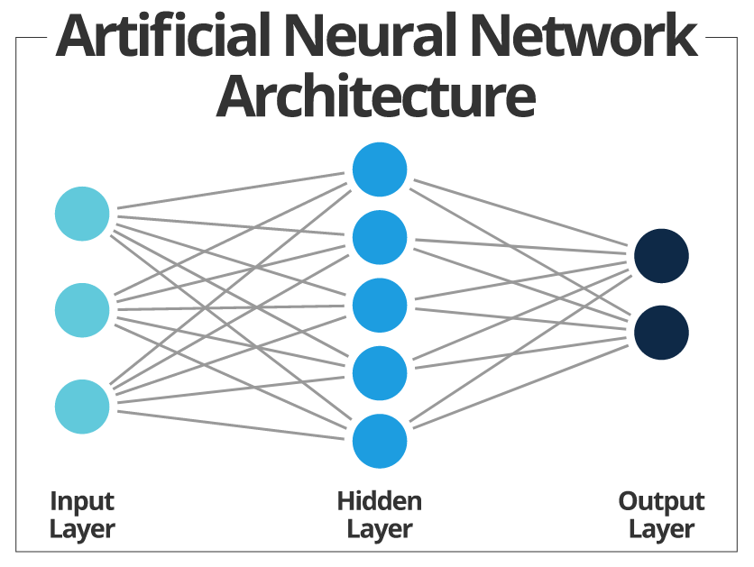

Artificial neural networks, usually simply called neural networks, are computing systems vaguely inspired by the biological neural networks that constitute animal brains. An ANN is based on a collection of connected units or nodes called artificial neurons, which loosely model the neurons in a biological brain.

There are many types of neural network few are given below

1. Artificial neural network.
2. Recurrent neural network.
3. Convolution neural network.

As we have already mentioned CNN dozens of times so what is a CNN model?

In deep learning, a **convolutional neural network** (**CNN**, or **ConvNet**) is a class of deep neural networks, most commonly applied to analyzing visual imagery. They are also known as **shift invariant** or **space invariant artificial neural networks** (**SIANN**), based on the shared-weight architecture of the convolution kernels that scan the hidden layers and translation invariance characteristics. They have applications in image and video recognition, recommender systems, image classification, Image segmentation, medical image analysis, natural language processing, brain-computer interfaces, and financial time series.

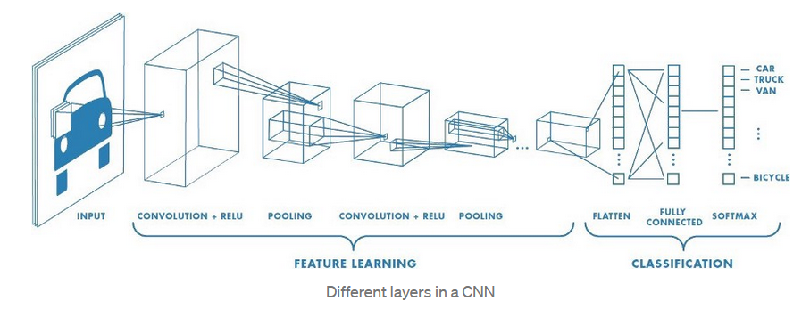

CNN has different layers as follows:

1) **Convolution layer:**

The main objective of convolution is to extract features such as edges, colors, corners from the input. As we go deeper inside the network, the network starts identifying more complex features such as shapes, digits, face parts as well.

2) **Pooling layer:**

This layer is solely to decrease the computational power required to process the data. It is done by decreasing the dimensions of the featured matrix even more. In this layer, we try to extract the dominant features from a restricted amount of neighborhood. Let us make it clear by taking an example.

Above two layers are always put in pairs and can be placed more than once depending on the type of data.

3) **Fully connected layer:**

Till now we haven’t done anything about classifying different images, what we have done is highlighted some features in an image and reduces the dimensions of the image drastically.

From here on, we are actually going to do the classification process.

Now that we have converted our input image into a suitable form for our Multi-Level fully connected architecture, we shall flatten the image into one column vector. The flattened output is fed to a feed-forward neural network and backpropagation applied to every iteration of training. Over a series of epochs, the model can distinguish between dominating and certain low-level features in images and classify them.

**SOFTWARES USED**

Programming language – python 3.8.5

**FLOWCHART**

**1) GetData_BW:**

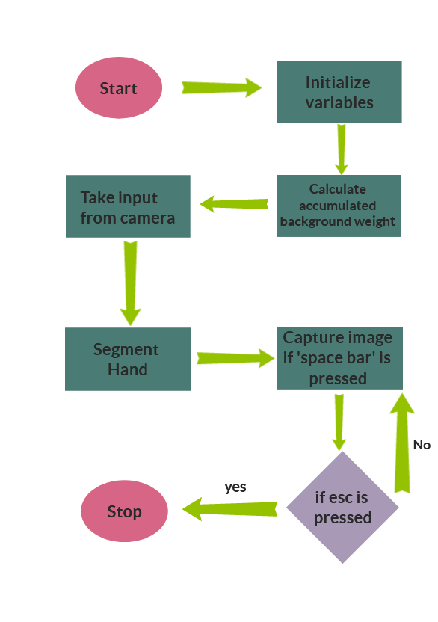

**Explanation**

**Step 1: Initializing Variables**

* Firstly, we import OpenCV, NumPy and other required modules then we declare all the required variables.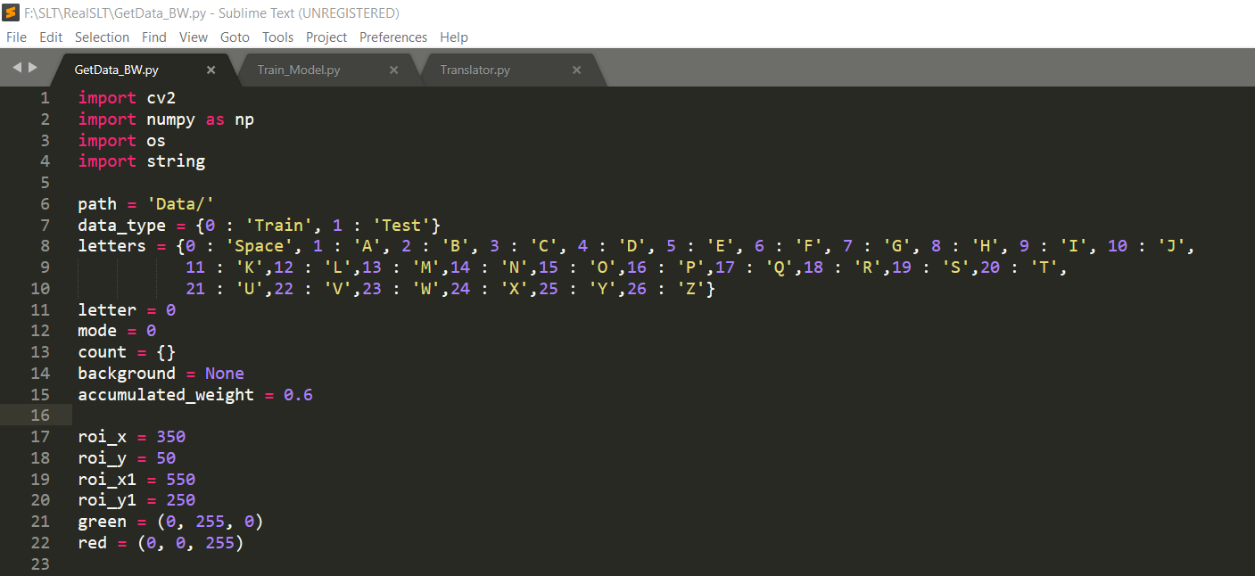 Fig (a)

**Step 2: Calculating accumulated background weight**

* Then we write functions for calculating accumulated background weight and we create trackbars to decide where and which letter’s image we are capturing right now and since trackbars requires a function as an argument to work we create a function without any operation to pass as an argument because our program don’t need and function argument that’s why we created an empty function ‘a’.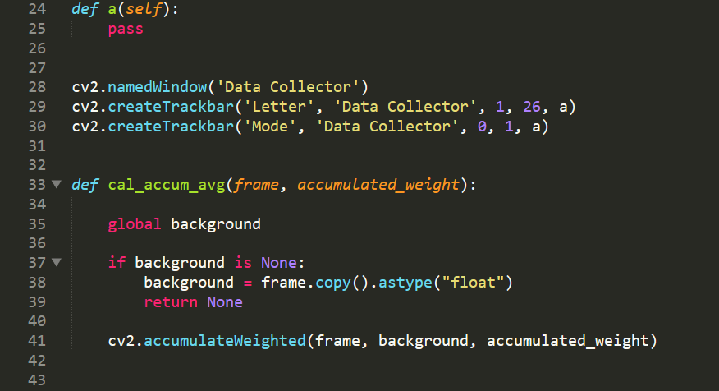 Fig(b)

**Step 3: Take input from camera**

* To take input from camera we use built-in OpenCV method ‘VideoCapture(0)’ here ‘0’ is given as a parameter because it stands for input from primary camera and we need to put it in a loop to get input from camera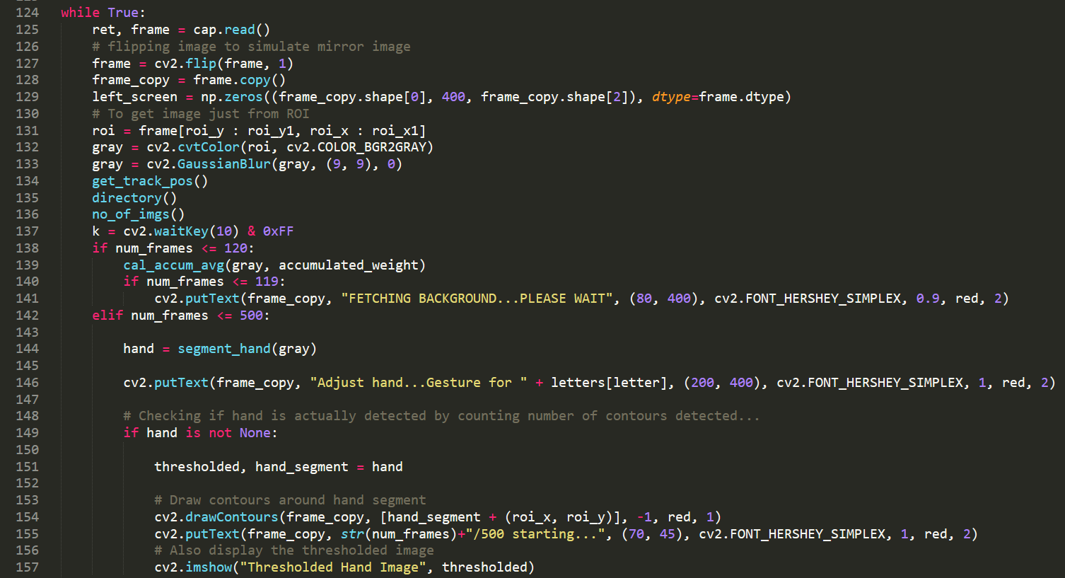 fig(c)
* In above image as you can see, we use cap.read() to read input from camera then we flip image to simulate mirror for better understanding then we declare region of interest in which user will keep his hand to capture image of sign we have also called several functions such as “get_track_pos()”, “directory()” and “no_of_images” their functions are as following
  + get_track_pos(): This function is used to get trackbars position whenever user changes them 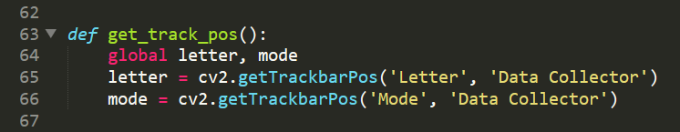 fig(c-1)
  + directory(): This function is used to check whether directory for all letters and mode exists or not if they don’t then it creates those directories which didn’t exist before 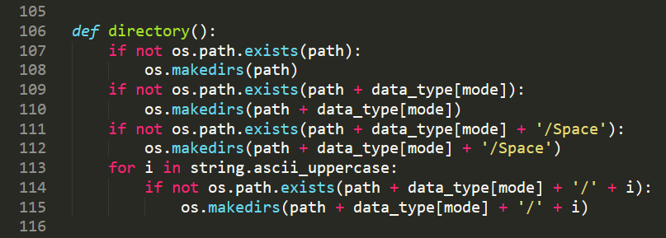 fig(c-2)
  + no_of_images(): This function is used to count and display no of images captured of letters in their respective directories. 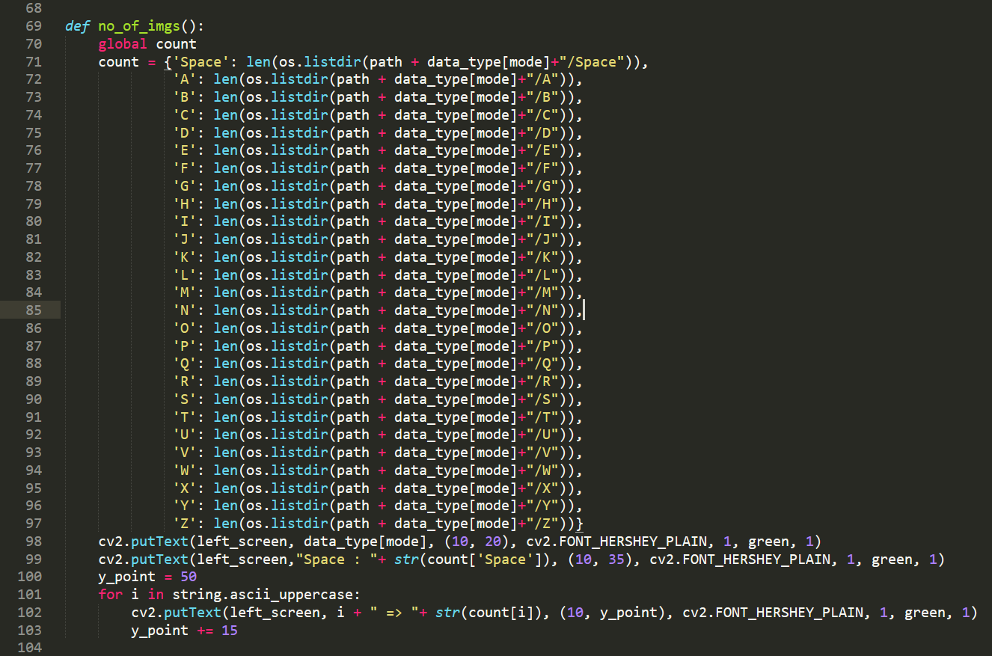 fig(c-3)
* As you can see in fig(c) we call all of the above functions in loop to keep track of all the data then we have a variable ‘num_frames’ we capture 120 frames to calculate accumulated weight of background which is necessary for segmenting hand from background after that we wait for 500 frames to give time to user to place their hand in region of interest to capture image depending on the number of contours, we decide whether user has placed their hand in region of interest or not.

**Step 4: Segment hand**

* Now we use segment_hand() function which is also in loop to differentiate hand from background and we first read image from camera in grayscale then we pass it as an argument to segment_hand() function which differentiates it from background and then convert it into binary image where hand is in white and everything else is black, we will use this binary image to train our model. 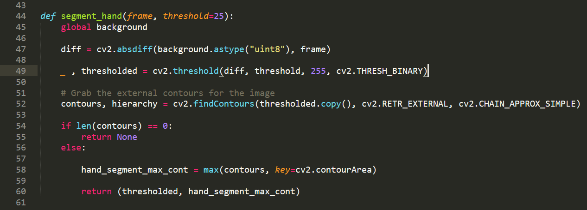 fig(d)

**Step 5: Capture image**

* When we have chosen letter and mode for the image, we can capture image by pressing spacebar key. This image will be saved in their respective directories with the name as an integer, this integer is the position of image in their directories.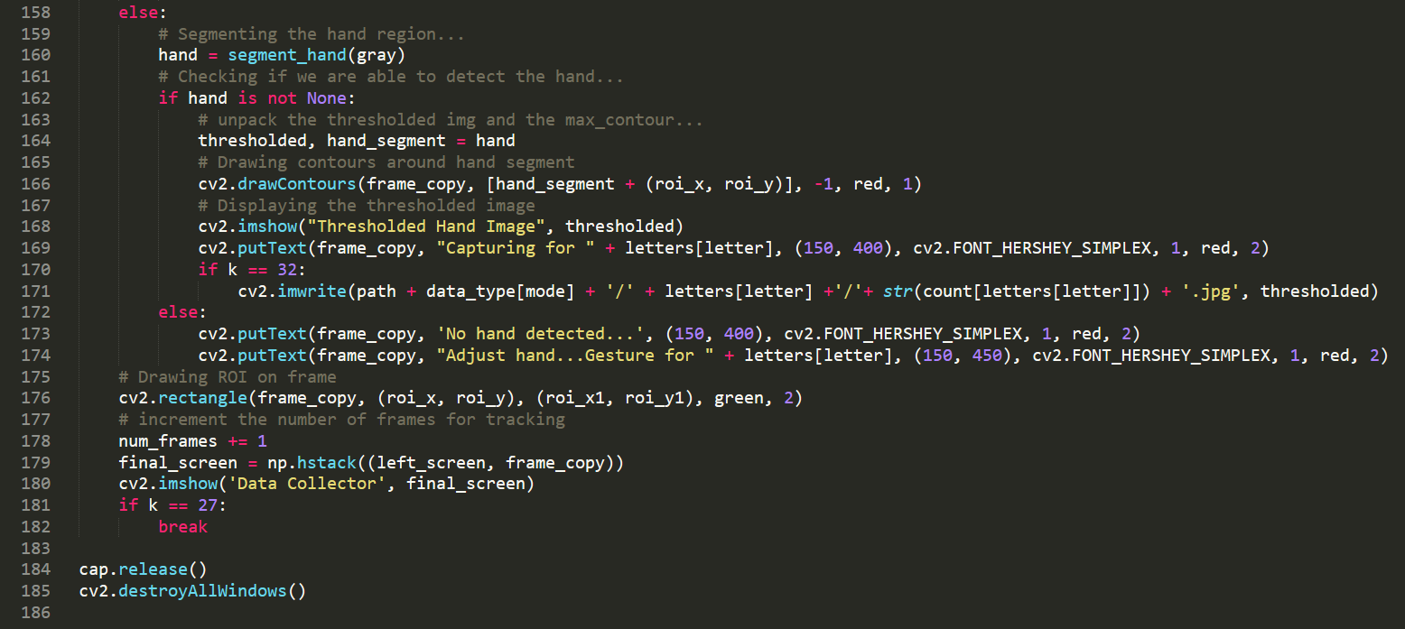 fig(e)
* When we are done capturing images, we can press ‘esc’ key to close the program then program releases camera and destroy all windows.

**CODE**

**import** **cv2**

**import** **numpy** **as** **np**

**import** **os**

**import** **string**

path = 'Data/'

data_type = {0 : 'Train', 1 : 'Test'}

letters = {0 : 'Space', 1 : 'A', 2 : 'B', 3 : 'C', 4 : 'D', 5 : 'E', 6 : 'F', 7 : 'G', 8 : 'H', 9 : 'I', 10 : 'J',

11 : 'K',12 : 'L',13 : 'M',14 : 'N',15 : 'O',16 : 'P',17 : 'Q',18 : 'R',19 : 'S',20 : 'T',

21 : 'U',22 : 'V',23 : 'W',24 : 'X',25 : 'Y',26 : 'Z'}

letter = 0

mode = 0

count = {}

background = None

accumulated_weight = 0.6

roi_x = 350

roi_y = 50

roi_x1 = 550

roi_y1 = 250

green = (0, 255, 0)

red = (0, 0, 255)

**def** a(self):

**pass**

cv2.namedWindow('Data Collector')

cv2.createTrackbar('Letter', 'Data Collector', 1, 26, a)

cv2.createTrackbar('Mode', 'Data Collector', 0, 1, a)

**def** cal_accum_avg(frame, accumulated_weight):

**global** background

**if** background **is** None:

background = frame.copy().astype("float")

**return** None

cv2.accumulateWeighted(frame, background, accumulated_weight)

**def** segment_hand(frame, threshold=25):

**global** background

diff = cv2.absdiff(background.astype("uint8"), frame)

_ , thresholded = cv2.threshold(diff, threshold, 255, cv2.THRESH_BINARY)

*# Grab the external contours for the image*

contours, hierarchy = cv2.findContours(thresholded.copy(), cv2.RETR_EXTERNAL, cv2.CHAIN_APPROX_SIMPLE)

**if** len(contours) == 0:

**return** None

**else**:

hand_segment_max_cont = max(contours, key=cv2.contourArea)

**return** (thresholded, hand_segment_max_cont)

**def** get_track_pos():

**global** letter, mode

letter = cv2.getTrackbarPos('Letter', 'Data Collector')

mode = cv2.getTrackbarPos('Mode', 'Data Collector')

**def** no_of_imgs():

**global** count

count = {'Space': len(os.listdir(path + data_type[mode]+"/Space")),

'A': len(os.listdir(path + data_type[mode]+"/A")),

'B': len(os.listdir(path + data_type[mode]+"/B")),

'C': len(os.listdir(path + data_type[mode]+"/C")),

'D': len(os.listdir(path + data_type[mode]+"/D")),

'E': len(os.listdir(path + data_type[mode]+"/E")),

'F': len(os.listdir(path + data_type[mode]+"/F")),

'G': len(os.listdir(path + data_type[mode]+"/G")),

'H': len(os.listdir(path + data_type[mode]+"/H")),

'I': len(os.listdir(path + data_type[mode]+"/I")),

'J': len(os.listdir(path + data_type[mode]+"/J")),

'K': len(os.listdir(path + data_type[mode]+"/K")),

'L': len(os.listdir(path + data_type[mode]+"/L")),

'M': len(os.listdir(path + data_type[mode]+"/M")),

'N': len(os.listdir(path + data_type[mode]+"/N")),

'O': len(os.listdir(path + data_type[mode]+"/O")),

'P': len(os.listdir(path + data_type[mode]+"/P")),

'Q': len(os.listdir(path + data_type[mode]+"/Q")),

'R': len(os.listdir(path + data_type[mode]+"/R")),

'S': len(os.listdir(path + data_type[mode]+"/S")),

'T': len(os.listdir(path + data_type[mode]+"/T")),

'U': len(os.listdir(path + data_type[mode]+"/U")),

'V': len(os.listdir(path + data_type[mode]+"/V")),

'W': len(os.listdir(path + data_type[mode]+"/W")),

'X': len(os.listdir(path + data_type[mode]+"/X")),

'Y': len(os.listdir(path + data_type[mode]+"/Y")),

'Z': len(os.listdir(path + data_type[mode]+"/Z"))}

cv2.putText(left_screen, data_type[mode], (10, 20), cv2.FONT_HERSHEY_PLAIN, 1, green, 1)

cv2.putText(left_screen,"Space : "+ str(count['Space']), (10, 35), cv2.FONT_HERSHEY_PLAIN, 1, green, 1)

y_point = 50

**for** i **in** string.ascii_uppercase:

cv2.putText(left_screen, i + " => "+ str(count[i]), (10, y_point), cv2.FONT_HERSHEY_PLAIN, 1, green, 1)

y_point += 15

**def** directory():

**if** **not** os.path.exists(path):

os.makedirs(path)

**if** **not** os.path.exists(path + data_type[mode]):

os.makedirs(path + data_type[mode])

**if** **not** os.path.exists(path + data_type[mode] + '/Space'):

os.makedirs(path + data_type[mode] + '/Space')

**for** i **in** string.ascii_uppercase:

**if** **not** os.path.exists(path + data_type[mode] + '/' + i):

os.makedirs(path + data_type[mode] + '/' + i)

cap = cv2.VideoCapture(0)

num_frames = 0

**while** True:

ret, frame = cap.read()

*# flipping image to simulate mirror image*

frame = cv2.flip(frame, 1)

frame_copy = frame.copy()

left_screen = np.zeros((frame_copy.shape[0], 400, frame_copy.shape[2]), dtype=frame.dtype)

*# To get image just from ROI*

roi = frame[roi_y : roi_y1, roi_x : roi_x1]

gray = cv2.cvtColor(roi, cv2.COLOR_BGR2GRAY)

gray = cv2.GaussianBlur(gray, (9, 9), 0)

get_track_pos()

directory()

no_of_imgs()

k = cv2.waitKey(10) & 0xFF

**if** num_frames <= 120:

cal_accum_avg(gray, accumulated_weight)

**if** num_frames <= 119:

cv2.putText(frame_copy, "FETCHING BACKGROUND...PLEASE WAIT", (80, 400), cv2.FONT_HERSHEY_SIMPLEX, 0.9, red, 2)

**elif** num_frames <= 500:

hand = segment_hand(gray)

cv2.putText(frame_copy, "Adjust hand...Gesture for " + letters[letter], (200, 400), cv2.FONT_HERSHEY_SIMPLEX, 1, red, 2)

*# Checking if hand is actually detected by counting number of contours detected...*

**if** hand **is** **not** None:

thresholded, hand_segment = hand

*# Draw contours around hand segment*

cv2.drawContours(frame_copy, [hand_segment + (roi_x, roi_y)], -1, red, 1)

cv2.putText(frame_copy, str(num_frames)+"/500 starting...", (70, 45), cv2.FONT_HERSHEY_SIMPLEX, 1, red, 2)

*# Also display the thresholded image*

cv2.imshow("Thresholded Hand Image", thresholded)

**else**:

*# Segmenting the hand region...*

hand = segment_hand(gray)

*# Checking if we are able to detect the hand...*

**if** hand **is** **not** None:

*# unpack the thresholded img and the max_contour...*

thresholded, hand_segment = hand

*# Drawing contours around hand segment*

cv2.drawContours(frame_copy, [hand_segment + (roi_x, roi_y)], -1, red, 1)

*# Displaying the thresholded image*

cv2.imshow("Thresholded Hand Image", thresholded)

cv2.putText(frame_copy, "Capturing for " + letters[letter], (150, 400), cv2.FONT_HERSHEY_SIMPLEX, 1, red, 2)

**if** k == 32:

cv2.imwrite(path + data_type[mode] + '/' + letters[letter] +'/'+ str(count[letters[letter]]) + '.jpg', thresholded)

**else**:

cv2.putText(frame_copy, 'No hand detected...', (150, 400), cv2.FONT_HERSHEY_SIMPLEX, 1, red, 2)

cv2.putText(frame_copy, "Adjust hand...Gesture for " + letters[letter], (150, 450), cv2.FONT_HERSHEY_SIMPLEX, 1, red, 2)

*# Drawing ROI on frame*

cv2.rectangle(frame_copy, (roi_x, roi_y), (roi_x1, roi_y1), green, 2)

*# increment the number of frames for tracking*

num_frames += 1

final_screen = np.hstack((left_screen, frame_copy))

cv2.imshow('Data Collector', final_screen)

**if** k == 27:

**break**

cap.release()

cv2.destroyAllWindows()

**OUTPUT**

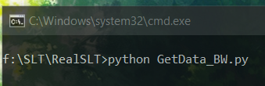

Fig. 1

Above is the input for running code this code was run in command prompt

Given below is the output of the code written above

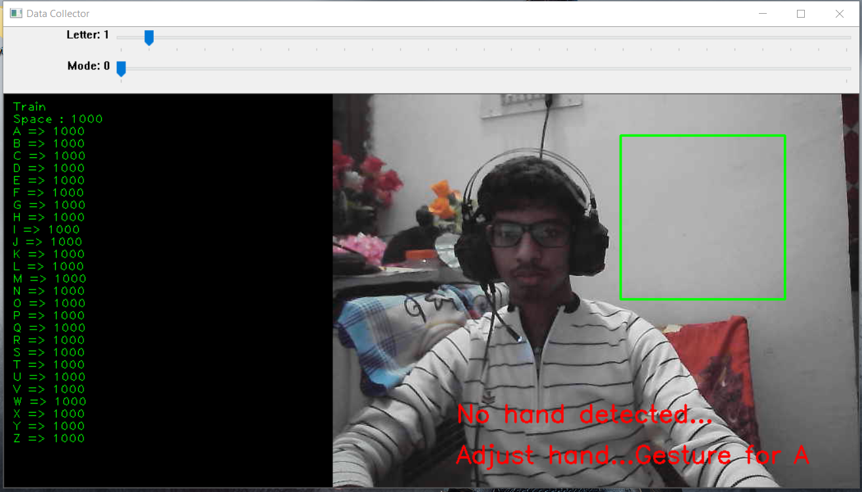

Fig. 2

In the left side of window, it is showing number of images of the letters captured and saved in their respective directories and trackbars above can be adjusted to change the directory for different letters and different modes such as ‘train’ and ‘test’ since there is nothing in region of interest therefore it is showing “No hand detected”.

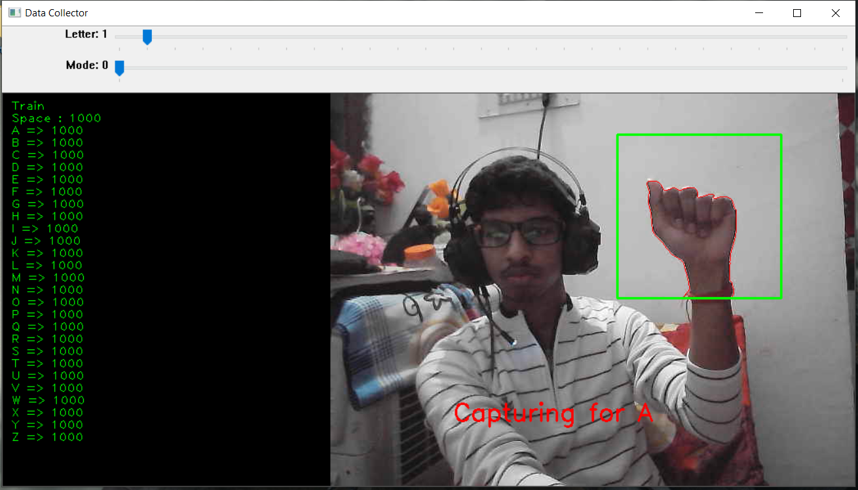

Fig. 3

In the above image Apurv is placing his hand in the region of interest (Green Rectangle)

To capture image of sign as mentioned above in the explanation section program processes image in the region of interest into a binary image which is given below

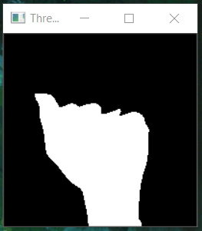

Fig. 3.1

By changing position of trackbars we can change directory in which we want to save our processed image given below is the output when we change trackbars for letter and mode to ‘test’ from ‘train’.

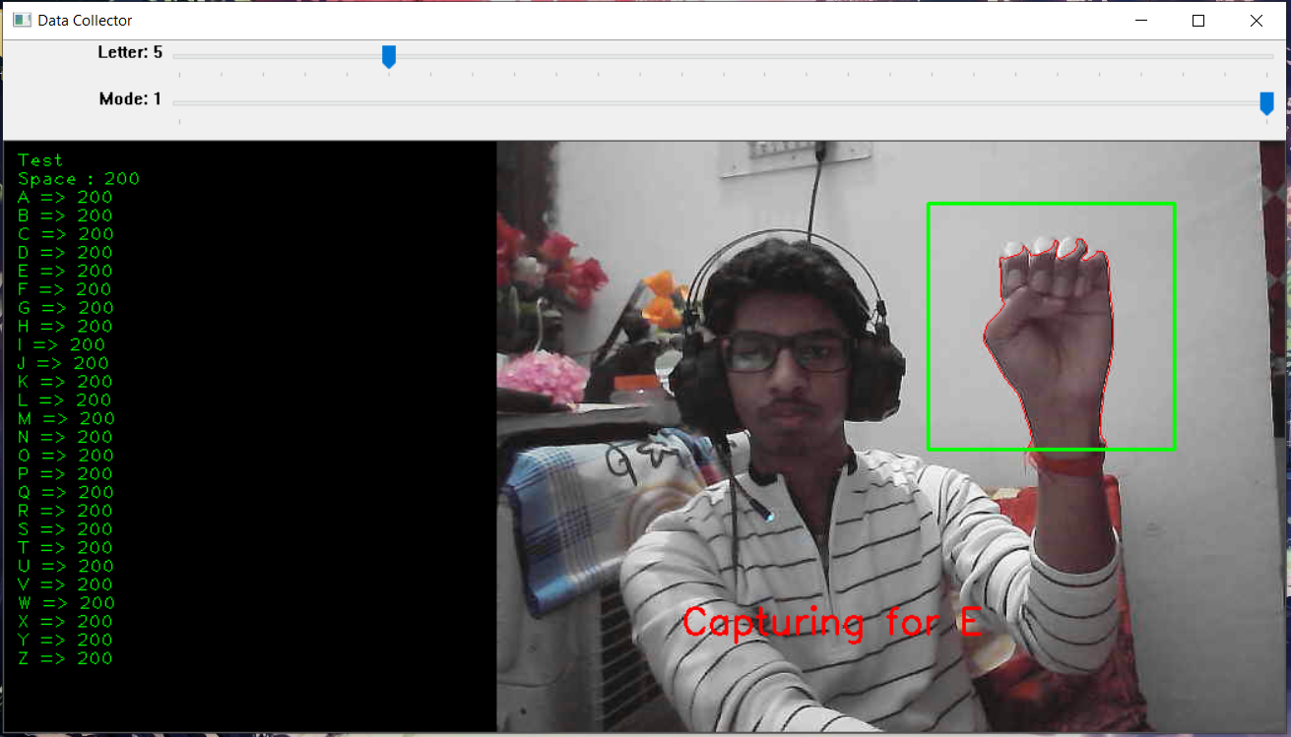

Fig. 4

Here number of images for testing data is 200 for each letter processed image from region of interest is given below

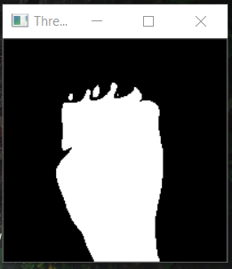

Fig. 4.1

Fig. 4.1 shows the binary image for letter ‘E’, this program will until esc is pressed.

**FLOWCHART**

**2) Train_Model:**

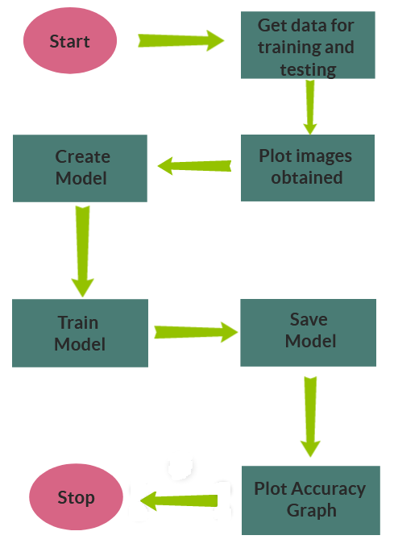

**Explanation**

**Step 1: Get data for training and testing**

* There are certain steps which we are supposed to follow for training model those steps are listed below
* Getting data: First we get data from the source which we require for training model.
* Cleaning data: After that we clean our data that is, we remove all unwanted data, and we make our data even for example in this project we have 1000 images for each letter we require same number of images for each letter we cannot have uneven number of images for different letter.
* Separating data: Then we separate data for training and testing ideal separating percentage is we keep 70-80% for training and 30-20% for testing in this project we have 80% for training and 20% for testing.
* Training model: Then we feed this data to our model to train it and then we use test data for testing accuracy of our model.
* Saving model: Then we finally save model for later use.
* Since we have created our data ourselves there we do not need to clean and separate our data it is already clean and divide in two sets for training and testing.
* Now we fetch our data from their respective folders and feed it to our model for training 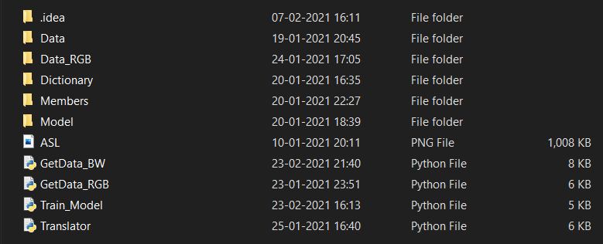 Fig. 5.1

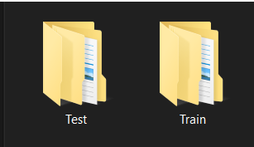

Fig. 5.2

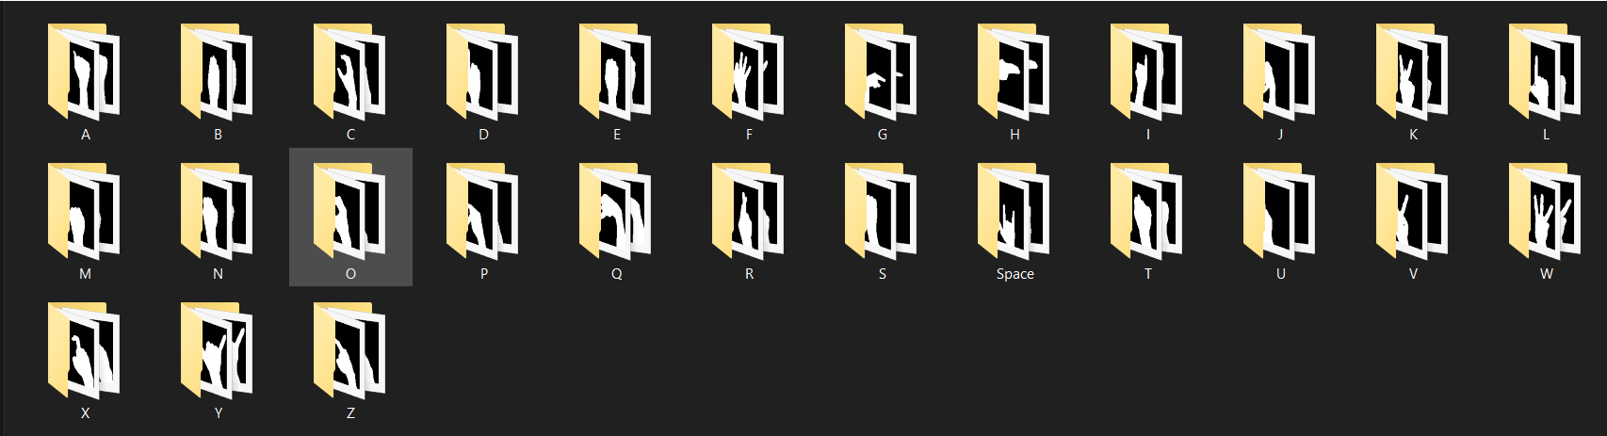 Fig. 5.3

* Now in our program first we import all the required modules and then we fetch data using built-in methods of Keras module 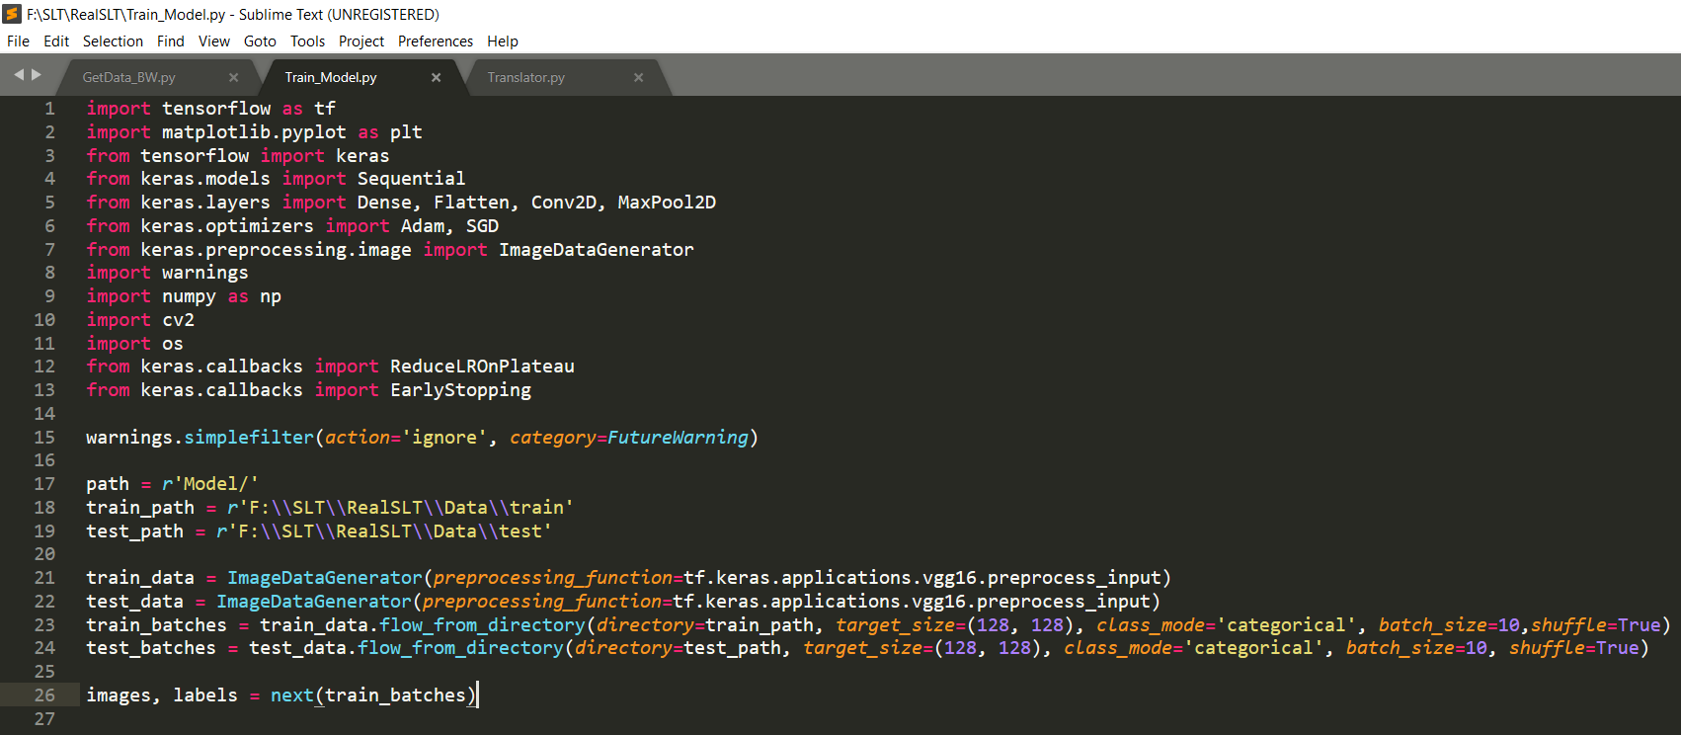 Fig.6

As you can see, we get our data for training and testing both we created 10 batches for each, and we have reduced image to 128x128 in size then we unpack it into images and labels

**Step 2: Plot sample images Obtained**

* Now we plot obtained sample images in 128x128 size with their labels which we will be using for training our model 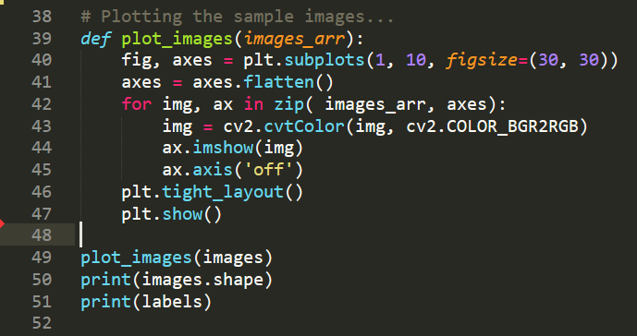 Fig. 7 Here we have called function plot_images() to plot sample images and labels.

**Step 3: Create Model**

* Now with the help of Keras we create our model we are using sequential type of model 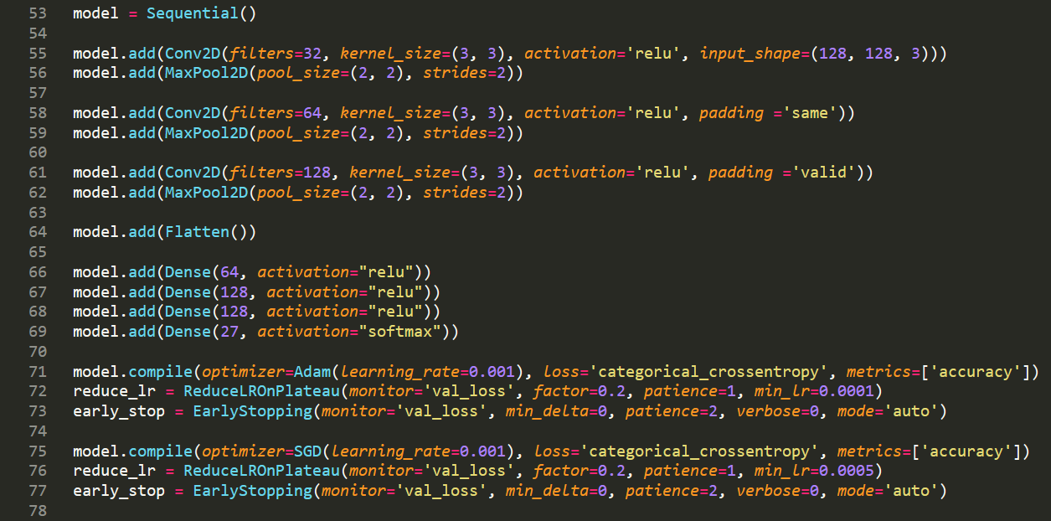 Fig.8 We created our model then added three convolutional and pooling layers after that, we flatten our data to create a list-like structure of data and then using dense layer, we reduced the size of data to make it easier for our model to train, and then we compile our model and set several parameters which we help us to achieve maximum accuracy, all the parameters and their working is listed below
* monitor: It is the quantity to be monitored.
* factor: this is the factor by which learning rate will be reduced.
* patience: number of epochs with no improvement after which learning rate will be reduced.
* min_lr: lower bound on the learning rate
* After That we decide When our model should stop using EarlyStopping() function this function also requires few parameter which are listed below
* monitor: It is the quantity to be monitored.
* min_delta: Minimum change in the monitored quantity to count it as an improvement.
* patience: Number of epochs with no improvement after which it will stop learning.
* verbose: verbosity mode.
* mode: one of {auto, min, max}. In `min` mode, training will stop when the quantity monitored has stopped decreasing; in `max` mode it will stop when the quantity monitored has stopped increasing; in `auto` mode, the direction is automatically inferred from the name of the monitored quantity.

**Step 4: Train Model**

* After we have created our model now, we will train our model using the sample images 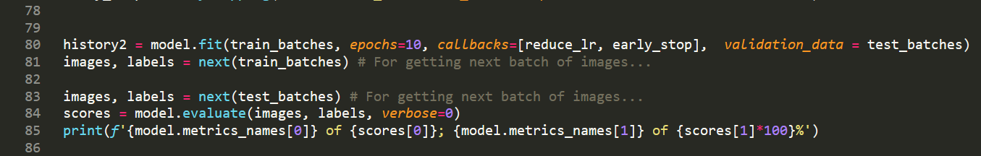 Fig.9 We train our model using fit() function and we give it few parameters which are listed below
* train_batches: these are sample images obtained in batches for training our model.
* epochs: Integer. Number of epochs to train the model. An epoch is an iteration over the entire `train_batches` and `test_batches` data provided.
* callbacks: List of callbacks to apply during training.
* validation_data: Data on which to evaluate the loss and any model metrics at the end of each epoch. The model will not be trained on this data.

**Step 5: Save Model**

* Now we will save our trained model and test its accuracy, we will also print properties of our model 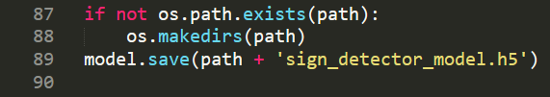 Fig. 10
* As shown in fig. 10 we first check whether directory where we will save our model exists or not if it does not exist then, we create directory and save our model in it in HDF5 format.
* Now we load our saved model and test it using test_batches we print results on our terminal 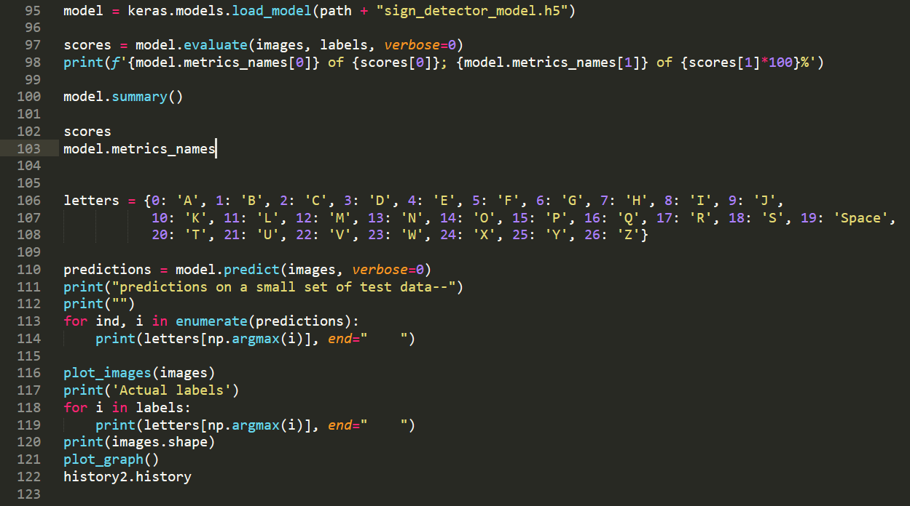 Fig.11
* AS shown in Fig.11 we first load our model then we evaluate our model and print its score on terminal using summary() function, we show details of our model after that we use our model to predict few signs to check its accuracy and then again we plot images which we are predicting for better insight.

**Step 6: Plot Accuracy Graph**

* Now when we have tested our model we will plot graph of accuracy of our model using matplotlib module 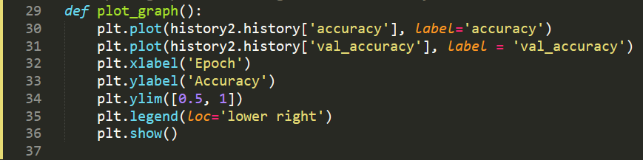 Fig.12
* As shown in fig.12 we call this function at the end of our program to check accuracy of our model we plot a graph with epoch on x-axis and accuracy on y-axis.

**CODE**

**import** **tensorflow** **as** **tf**

**import** **matplotlib.pyplot** **as** **plt**

**from** **tensorflow** **import** keras

**from** **keras.models** **import** Sequential

**from** **keras.layers** **import** Dense, Flatten, Conv2D, MaxPool2D

**from** **keras.optimizers** **import** Adam, SGD

**from** **keras.preprocessing.image** **import** ImageDataGenerator

**import** **warnings**

**import** **numpy** **as** **np**

**import** **cv2**

**import** **os**

**from** **keras.callbacks** **import** ReduceLROnPlateau

**from** **keras.callbacks** **import** EarlyStopping

warnings.simplefilter(action='ignore', category=**FutureWarning**)

path = r'Model/'

train_path = r'F:**\\**SLT**\\**RealSLT**\\**Data**\\**train'

test_path = r'F:**\\**SLT**\\**RealSLT**\\**Data**\\**test'

train_data = ImageDataGenerator(preprocessing_function=tf.keras.applications.vgg16.preprocess_input)

test_data = ImageDataGenerator(preprocessing_function=tf.keras.applications.vgg16.preprocess_input)

train_batches = train_data.flow_from_directory(directory=train_path, target_size=(128, 128), class_mode='categorical', batch_size=10,shuffle=True)

test_batches = test_data.flow_from_directory(directory=test_path, target_size=(128, 128), class_mode='categorical', batch_size=10, shuffle=True)

images, labels = next(train_batches)

*# To plot graph of learning rate and accuracy...*

**def** plot_graph():

plt.plot(history2.history['accuracy'], label='accuracy')

plt.plot(history2.history['val_accuracy'], label = 'val_accuracy')

plt.xlabel('Epoch')

plt.ylabel('Accuracy')

plt.ylim([0.5, 1])

plt.legend(loc='lower right')

plt.show()

*# Plotting the sample images...*

**def** plot_images(images_arr):

fig, axes = plt.subplots(1, 10, figsize=(30, 30))

axes = axes.flatten()

**for** img, ax **in** zip( images_arr, axes):

img = cv2.cvtColor(img, cv2.COLOR_BGR2RGB)

ax.imshow(img)

ax.axis('off')

plt.tight_layout()

plt.show()

plot_images(images)

**print**(images.shape)

**print**(labels)

model = Sequential()

model.add(Conv2D(filters=32, kernel_size=(3, 3), activation='relu', input_shape=(128, 128, 3)))

model.add(MaxPool2D(pool_size=(2, 2), strides=2))

model.add(Conv2D(filters=64, kernel_size=(3, 3), activation='relu', padding ='same'))

model.add(MaxPool2D(pool_size=(2, 2), strides=2))

model.add(Conv2D(filters=128, kernel_size=(3, 3), activation='relu', padding ='valid'))

model.add(MaxPool2D(pool_size=(2, 2), strides=2))

model.add(Flatten())

model.add(Dense(64, activation="relu"))

model.add(Dense(128, activation="relu"))

model.add(Dense(128, activation="relu"))

model.add(Dense(27, activation="softmax"))

model.compile(optimizer=Adam(learning_rate=0.001), loss='categorical_crossentropy', metrics=['accuracy'])

reduce_lr = ReduceLROnPlateau(monitor='val_loss', factor=0.2, patience=1, min_lr=0.0001)

early_stop = EarlyStopping(monitor='val_loss', min_delta=0, patience=2, verbose=0, mode='auto')

model.compile(optimizer=SGD(learning_rate=0.001), loss='categorical_crossentropy', metrics=['accuracy'])

reduce_lr = ReduceLROnPlateau(monitor='val_loss', factor=0.2, patience=1, min_lr=0.0005)

early_stop = EarlyStopping(monitor='val_loss', min_delta=0, patience=2, verbose=0, mode='auto')

history2 = model.fit(train_batches, epochs=10, callbacks=[reduce_lr, early_stop], validation_data = test_batches)

images, labels = next(train_batches) *# For getting next batch of images...*

images, labels = next(test_batches) *# For getting next batch of images...*

scores = model.evaluate(images, labels, verbose=0)

**print**(f'{model.metrics_names[0]} of {scores[0]}; {model.metrics_names[1]} of {scores[1]*100}%')

**if** **not** os.path.exists(path):

os.makedirs(path)

model.save(path + 'sign_detector_model.h5')

**print**(history2.history)

images, labels = next(test_batches)

model = keras.models.load_model(path + "sign_detector_model_2_90.h5")

scores = model.evaluate(images, labels, verbose=0)

**print**(f'{model.metrics_names[0]} of {scores[0]}; {model.metrics_names[1]} of {scores[1]*100}%')

model.summary()

scores

model.metrics_names

letters = {0: 'A', 1: 'B', 2: 'C', 3: 'D', 4: 'E', 5: 'F', 6: 'G', 7: 'H', 8: 'I', 9: 'J',

10: 'K', 11: 'L', 12: 'M', 13: 'N', 14: 'O', 15: 'P', 16: 'Q', 17: 'R', 18: 'S', 19: 'Space',

20: 'T', 21: 'U', 22: 'V', 23: 'W', 24: 'X', 25: 'Y', 26: 'Z'}

predictions = model.predict(images, verbose=0)

**print**("predictions on a small set of test data--")

**print**("")

**for** ind, i **in** enumerate(predictions):

**print**(letters[np.argmax(i)], end=" ")

plot_images(images)

**print**('Actual labels')

**for** i **in** labels:

**print**(letters[np.argmax(i)], end=" ")

**print**(images.shape)

plot_graph()

history2.history

**OUTPUT**

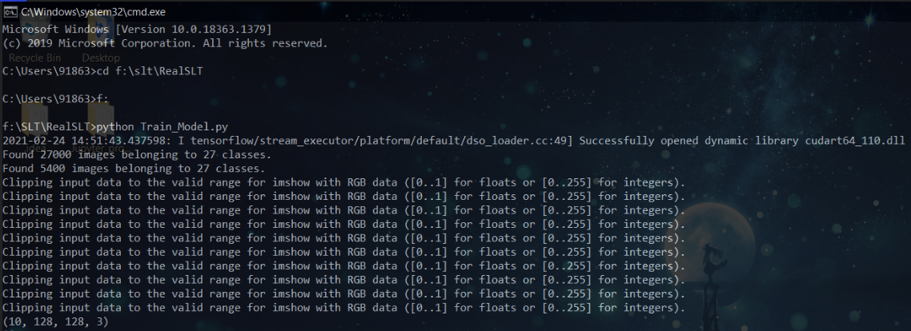

Fig. 13

In fig. 13 command for running our program is shown our program then searches for all image in dataset and uses it to train as shown we have total 27000 images for training and 5400 for testing our image has the size of 128x128.

After that when it fetches data it prints sample images on screen in a separate window as shown below 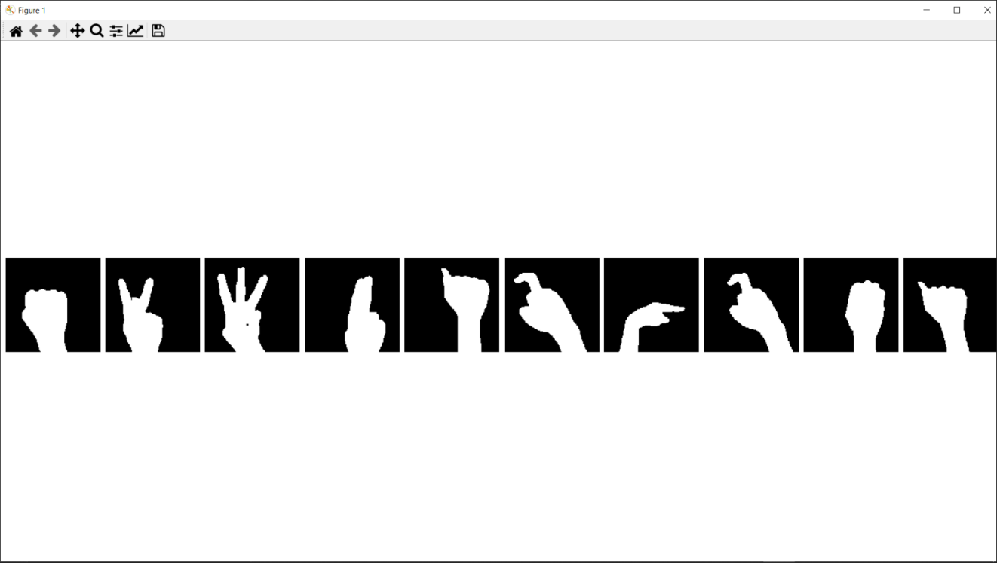

Fig. 14

Then our model trains over dataset for 10 epochs but since it cannot improve further after 3 epochs therefore it stops learning after 3 epochs and prints the score of our model such as loss and accuracy.

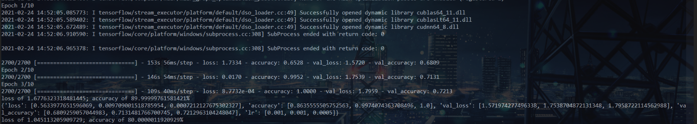

Fig. 15

Our model has achieved 80.00% of accuracy with a loss of 1.6776 but in our translator, we are using a model with the accuracy of 89.99%.

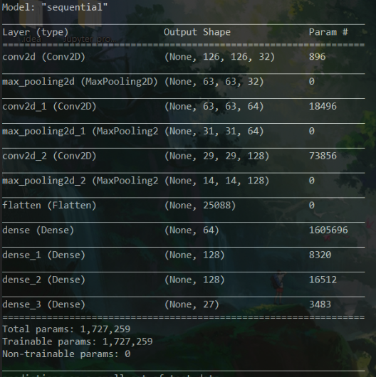 after it has finished training, we print characteristics of our model

Fig. 16

As mentioned earlier our model is of sequential type and it shows all the layers in our model which we have added to it

Then we make predictions on a small set of sample images first we print images which we are going to predict using model

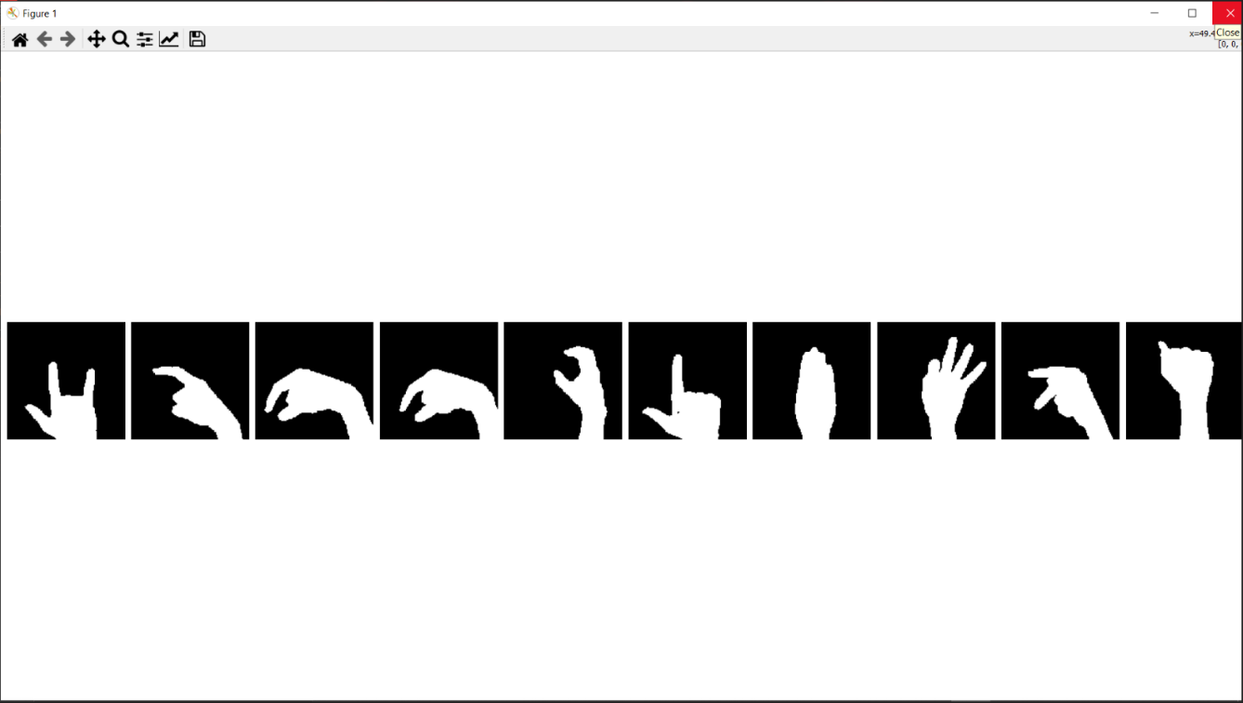

Fig. 17

After that we print results of our prediction as shown below

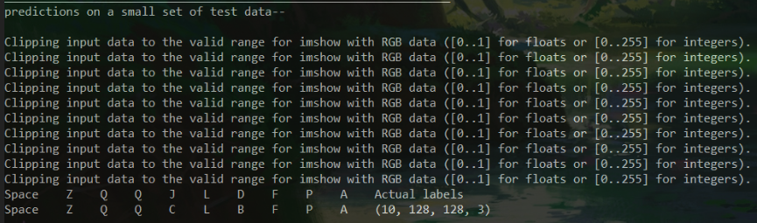

Fig. 18

It predicted 8 out of 10 labels correctly since the model which we are using is 80% accurate only achieving 100% is impossible since nothing is 100% efficient but we can increase our accuracy by using more than one model or providing more data, but it will increase training time significantly.

And then finally we plot our accuracy graph

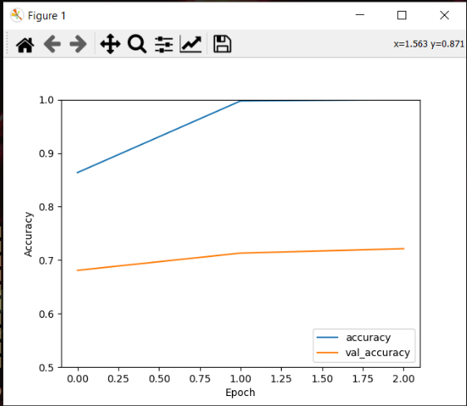

Fig. 19

This is the graph of accuracy and val_accuracy (accuracy of each batches separately) in a graph with accuracy on x-axis and epoch on y-axis.

**FLOWCHART**

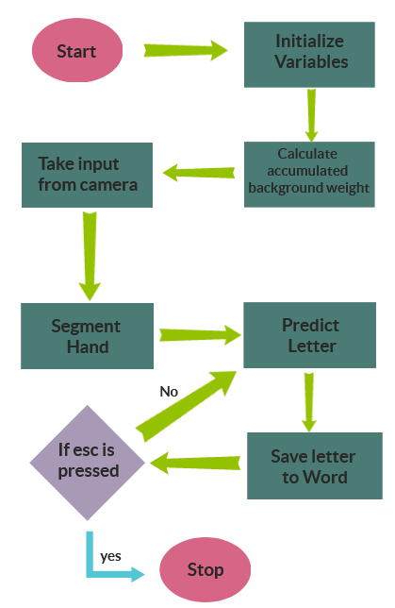**3) Translator:**

**Explanation**

**Step 1: Initializing Variables**

* First we import all the required modules and then we initialize all required variables which we will need in future and then we load our saved model. 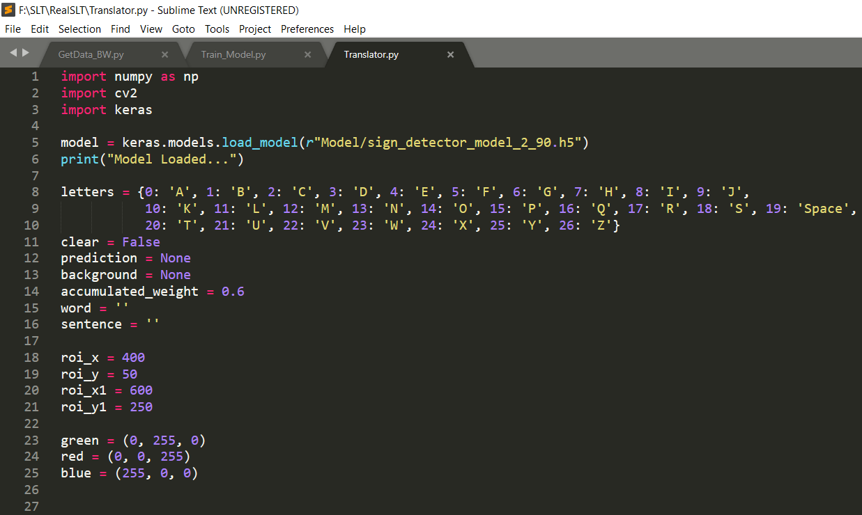

Fig. 20

**Step 2: Calculate accumulated background weight**

* Just like how we did in our first program to capture image similarly we calculate accumulated background weight to differentiate hand from background and use it to predict hand sign made by user.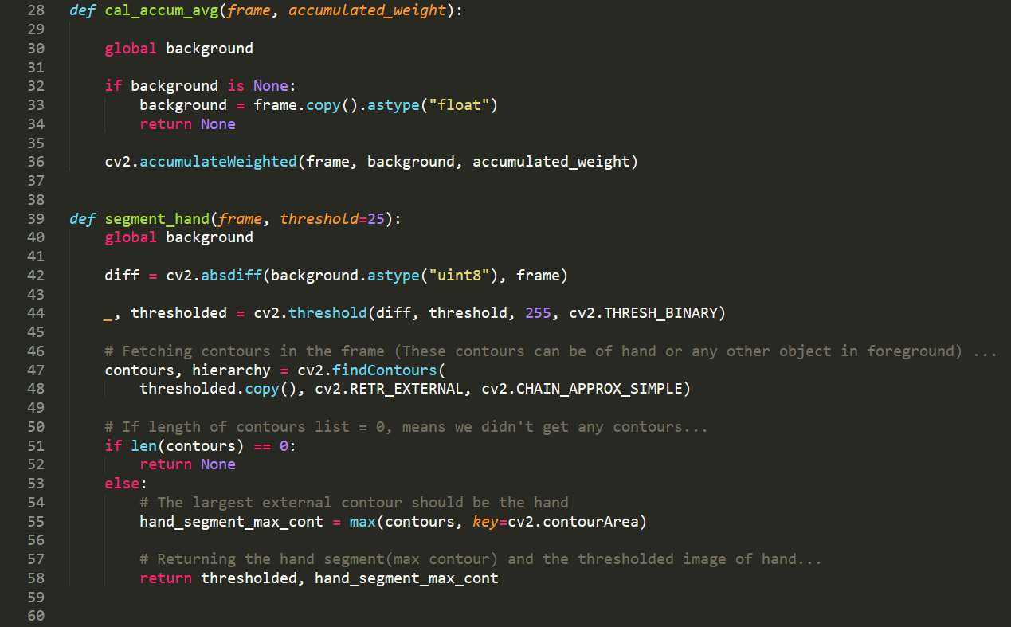

Fig. 21

* We also use the same function which we used in our first program to segment hand and we also write code for a simple GUI which will make it easier for user to use this translator.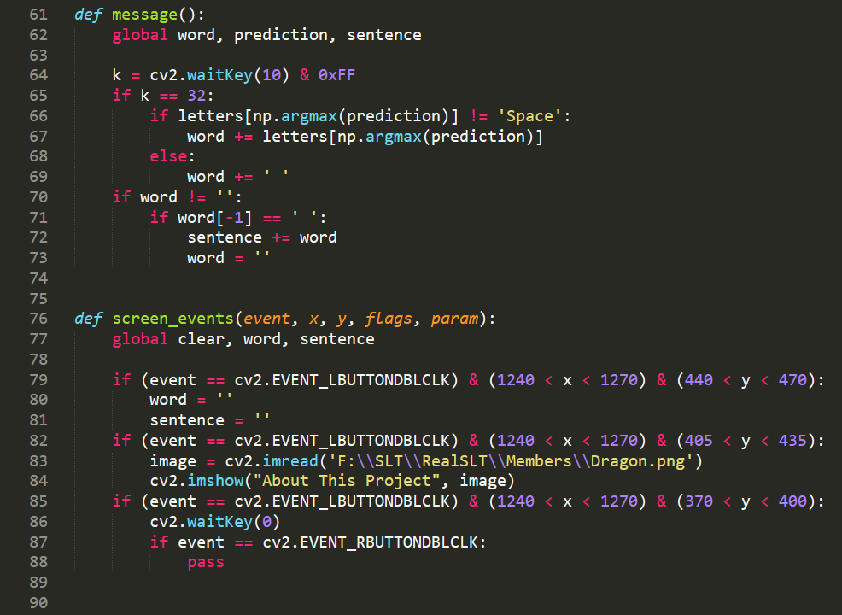

Fig. 22

* message() function is used to show and store predicted letter in two different strings “word” and “sentence” to show message which user wanted to convey using sign language .
* screen_events() function is used to register any screen events such as left mouse button click or cursor movement we will use this to determine whether user wants to see info about this project, clear message or pause this program.
* Given below in Fig. 23 is the function which we use to make GUI 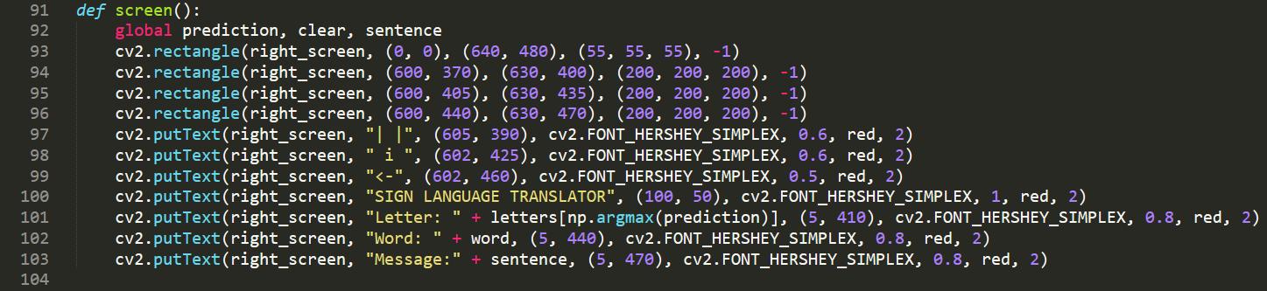

Fig. 23

* We use screen() function to draw all the shapes which we want as a GUI

**Step 3: Take input from camera**

* Now as we did in first program we take input from camera in similar manner and the we call functions for calculating accumulated background and segmenting hand we calculate accumulated weight of background for 120 frames and then we ask user to show hand signs and with the help of segment_hand() function we differentiate hand from background and use it to predict with the help of loaded model.

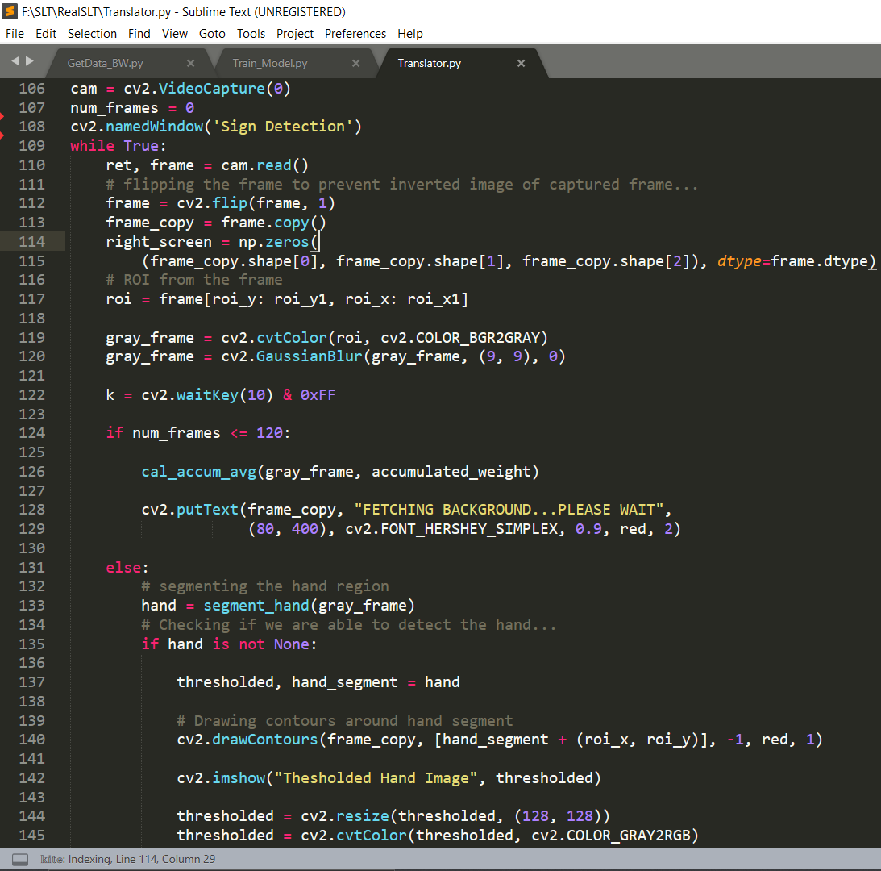

Fig. 24

**Step 4: Predict Letter**

* Now when we have segmented hand from background and processed image to predict model we will now use model.predict() function to predict and we will pass user’s hand image as a parameter output of this function is an integer ranging from 0 to 26 which the position of each letter in the alphabetical order.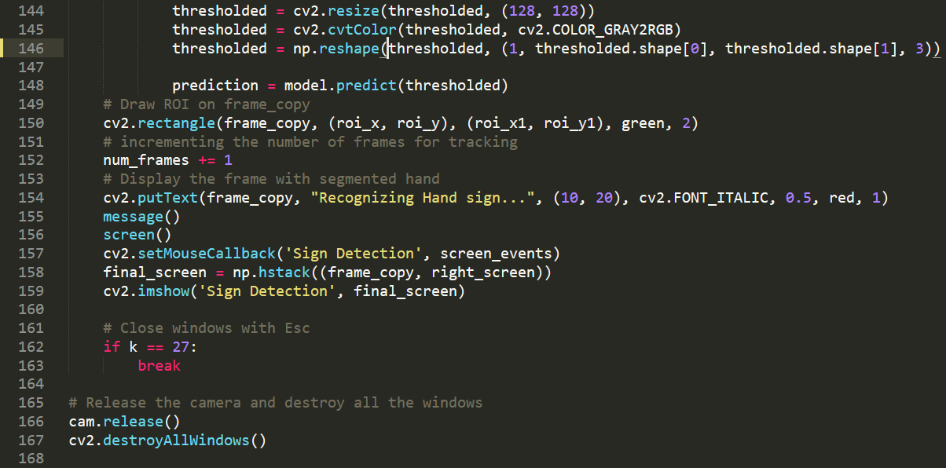

Fig. 25

**Step 5: Save Letter to Word**

* Now as mentioned earlier we use message() function to store predicted letter in “word” and “sentence” when we press spacebar key it will store letter since translator is not 100% accurate therefore we have kept spacebar key as input button when we enter space program resets “word” and copy the word formed in sentence and if we want to display another message there is clear button too which will reset both “word” and “sentence” string.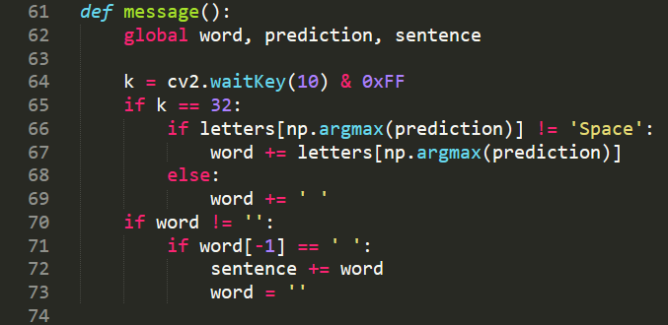

Fig. 26

* When we are finished with our program we can close our program by pressing esc key after which program releases camera and destroys all windows.

**CODE**

**import** **numpy** **as** **np**

**import** **cv2**

**import** **keras**

model = keras.models.load_model(r"Model/sign_detector_model_2_90.h5")

**print**("Model Loaded...")

letters = {0: 'A', 1: 'B', 2: 'C', 3: 'D', 4: 'E', 5: 'F', 6: 'G', 7: 'H', 8: 'I', 9: 'J',

10: 'K', 11: 'L', 12: 'M', 13: 'N', 14: 'O', 15: 'P', 16: 'Q', 17: 'R', 18: 'S', 19: 'Space',

20: 'T', 21: 'U', 22: 'V', 23: 'W', 24: 'X', 25: 'Y', 26: 'Z'}

clear = False

prediction = None

background = None

accumulated_weight = 0.6

word = ''

sentence = ''

roi_x = 400

roi_y = 50

roi_x1 = 600

roi_y1 = 250

green = (0, 255, 0)

red = (0, 0, 255)

blue = (255, 0, 0)

**def** cal_accum_avg(frame, accumulated_weight):

**global** background

**if** background **is** None:

background = frame.copy().astype("float")

**return** None

cv2.accumulateWeighted(frame, background, accumulated_weight)

**def** segment_hand(frame, threshold=25):

**global** background

diff = cv2.absdiff(background.astype("uint8"), frame)

_, thresholded = cv2.threshold(diff, threshold, 255, cv2.THRESH_BINARY)

*# Fetching contours in the frame (These contours can be of hand or any other object in foreground) ...*

contours, hierarchy = cv2.findContours(

thresholded.copy(), cv2.RETR_EXTERNAL, cv2.CHAIN_APPROX_SIMPLE)

*# If length of contours list = 0, means we didn't get any contours...*

**if** len(contours) == 0:

**return** None

**else**:

*# The largest external contour should be the hand*

hand_segment_max_cont = max(contours, key=cv2.contourArea)

*# Returning the hand segment(max contour) and the thresholded image of hand...*

**return** thresholded, hand_segment_max_cont

**def** message():

**global** word, prediction, sentence

k = cv2.waitKey(10) & 0xFF

**if** k == 32:

**if** letters[np.argmax(prediction)] != 'Space':

word += letters[np.argmax(prediction)]

**else**:

word += ' '

**if** word != '':

**if** word[-1] == ' ':

sentence += word

word = ''

**def** screen_events(event, x, y, flags, param):

**global** clear, word, sentence

**if** (event == cv2.EVENT_LBUTTONDBLCLK) & (1240 < x < 1270) & (440 < y < 470):

word = ''

sentence = ''

**if** (event == cv2.EVENT_LBUTTONDBLCLK) & (1240 < x < 1270) & (405 < y < 435):

image = cv2.imread('F:**\\**SLT**\\**RealSLT**\\**Members**\\**Dragon.png')

cv2.imshow("About This Project", image)

**if** (event == cv2.EVENT_LBUTTONDBLCLK) & (1240 < x < 1270) & (370 < y < 400):

cv2.waitKey(0)

**if** event == cv2.EVENT_RBUTTONDBLCLK:

**pass**

**def** screen():

**global** prediction, clear, sentence

cv2.rectangle(right_screen, (0, 0), (640, 480), (55, 55, 55), -1)

cv2.rectangle(right_screen, (600, 370), (630, 400), (200, 200, 200), -1)

cv2.rectangle(right_screen, (600, 405), (630, 435), (200, 200, 200), -1)

cv2.rectangle(right_screen, (600, 440), (630, 470), (200, 200, 200), -1)

cv2.putText(right_screen, "| |", (605, 390), cv2.FONT_HERSHEY_SIMPLEX, 0.6, red, 2)

cv2.putText(right_screen, " i ", (602, 425), cv2.FONT_HERSHEY_SIMPLEX, 0.6, red, 2)

cv2.putText(right_screen, "<-", (602, 460), cv2.FONT_HERSHEY_SIMPLEX, 0.5, red, 2)

cv2.putText(right_screen, "SIGN LANGUAGE TRANSLATOR", (100, 50), cv2.FONT_HERSHEY_SIMPLEX, 1, red, 2)

cv2.putText(right_screen, "Letter: " + letters[np.argmax(prediction)], (5, 410), cv2.FONT_HERSHEY_SIMPLEX, 0.8, red, 2)

cv2.putText(right_screen, "Word: " + word, (5, 440), cv2.FONT_HERSHEY_SIMPLEX, 0.8, red, 2)

cv2.putText(right_screen, "Message:" + sentence, (5, 470), cv2.FONT_HERSHEY_SIMPLEX, 0.8, red, 2)

cam = cv2.VideoCapture(0)

num_frames = 0

cv2.namedWindow('Sign Detection')

**while** True:

ret, frame = cam.read()

*# flipping the frame to prevent inverted image of captured frame...*

frame = cv2.flip(frame, 1)

frame_copy = frame.copy()

right_screen = np.zeros(

(frame_copy.shape[0], frame_copy.shape[1], frame_copy.shape[2]), dtype=frame.dtype)

*# ROI from the frame*

roi = frame[roi_y: roi_y1, roi_x: roi_x1]

gray_frame = cv2.cvtColor(roi, cv2.COLOR_BGR2GRAY)

gray_frame = cv2.GaussianBlur(gray_frame, (9, 9), 0)

k = cv2.waitKey(10) & 0xFF

**if** num_frames <= 120:

cal_accum_avg(gray_frame, accumulated_weight)

cv2.putText(frame_copy, "FETCHING BACKGROUND...PLEASE WAIT",

(80, 400), cv2.FONT_HERSHEY_SIMPLEX, 0.9, red, 2)

**else**:

*# segmenting the hand region*

hand = segment_hand(gray_frame)

*# Checking if we are able to detect the hand...*

**if** hand **is** **not** None:

thresholded, hand_segment = hand

*# Drawing contours around hand segment*

cv2.drawContours(frame_copy, [hand_segment + (roi_x, roi_y)], -1, red, 1)

cv2.imshow("Thesholded Hand Image", thresholded)

thresholded = cv2.resize(thresholded, (128, 128))

thresholded = cv2.cvtColor(thresholded, cv2.COLOR_GRAY2RGB)

thresholded = np.reshape(thresholded, (1, thresholded.shape[0], thresholded.shape[1], 3))

prediction = model.predict(thresholded)

*# Draw ROI on frame_copy*

cv2.rectangle(frame_copy, (roi_x, roi_y), (roi_x1, roi_y1), green, 2)

*# incrementing the number of frames for tracking*

num_frames += 1

*# Display the frame with segmented hand*

cv2.putText(frame_copy, "Recognizing Hand sign...", (10, 20), cv2.FONT_ITALIC, 0.5, red, 1)

message()

screen()

cv2.setMouseCallback('Sign Detection', screen_events)

final_screen = np.hstack((frame_copy, right_screen))

cv2.imshow('Sign Detection', final_screen)

*# Close windows with Esc*

**if** k == 27:

**break**

*# Release the camera and destroy all the windows*

cam.release()

cv2.destroyAllWindows()

**OUTPUT**

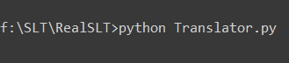To start translator program, we must write the following command in terminal to run our program

When the model is loaded it will print “Model Loaded…” message on terminal



After that it will run our program and the output obtained is given below

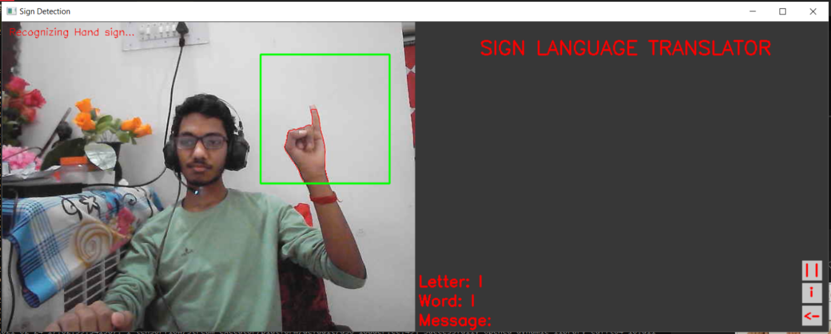

Fig. 27

Here Anusk from our group is trying to show how this translator works he is making hand sign of letter ‘I’ and our model is predicting and then it later saves it to ‘word’ section

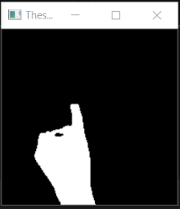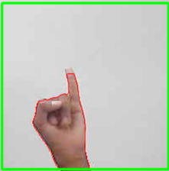Our program converts image from fig. 27a to Fig. 27b

Fig. 27a Fig. 27b

When we enter space, it resets ‘word’ and copy word formed to ‘sentence’ section and in a similar manner we can convey our message using sign language and this translator.

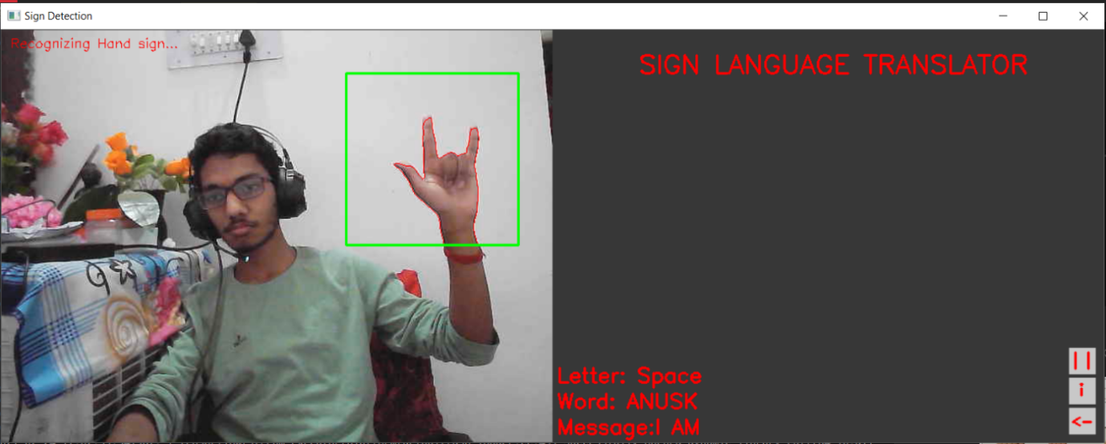

Fig. 28

As we can see there are three different buttons with three different functions when we use

1.  This button it pauses our program, and we can resume by pressing cross button in the upper right corner of window.
2.  This button is used to display information about this project. 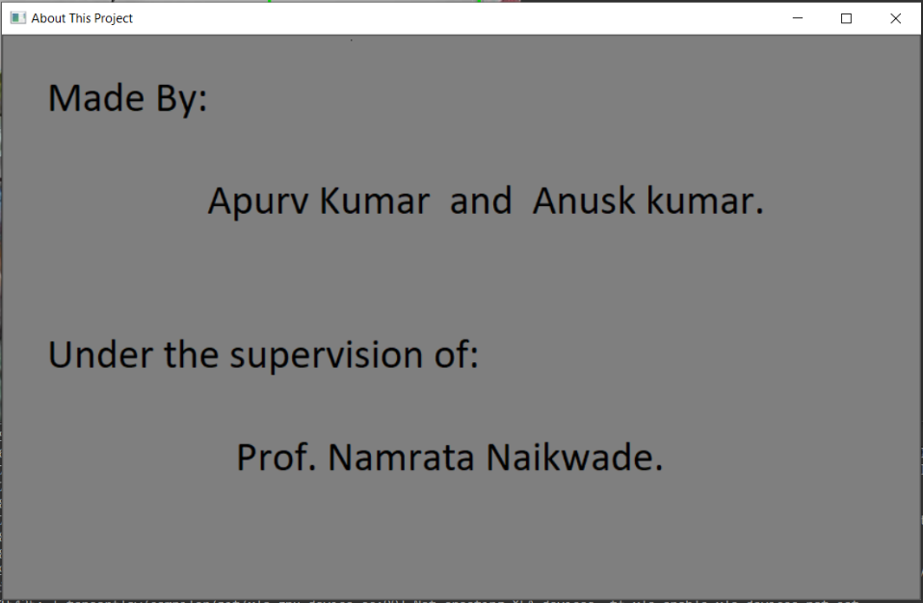

Fig. 29

1. 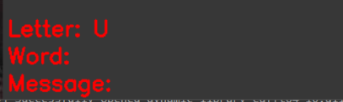 This button is used to clear any message to display new message by user 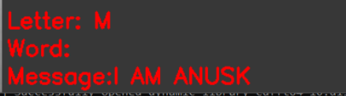

Fig.30a Fig. 30b

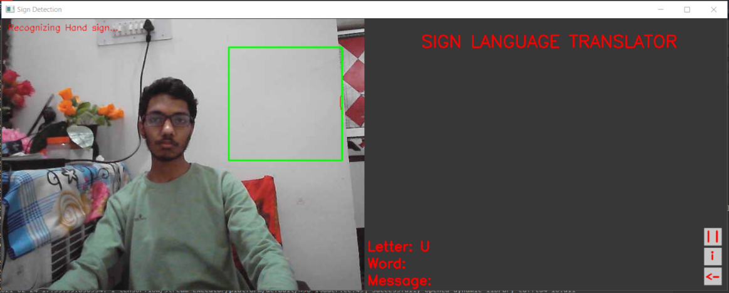In similar manner user can enter the message which he wants to display using sign language

Fig. 31

**CONCLUSION AND FUTURE ENHANCEMENTS**

* This project is good for translating simple messages but is only limited to hand signs thus we can improve it in future recognize gestures which have certain meaning.
* This translator requires stable background and good lighting condition which one of the major drawbacks of this project.
* We can make this project available on mobile devices so that it will be more easily available to use.

**GLOSSARY**

* **Machine Learning:** Machine learning is a method of data analysis that automates analytical model building.
* **Computer vision:** Computer vision is a field of artificial intelligence that trains computers to interpret and understand the visual world. Using digital images from cameras and videos and deep learning models, machines can accurately identify and classify objects — and then react to what they “see.”
* **Dataset:** A dataset is the base of all multivariate data analysis, often also called a data matrix. It is made up of values of several different variables for several observations. The data are collected in a data matrix (data table) of N rows and K columns, often denoted X. The N rows in the table are termed observations. The K columns are termed variables.

**REFERENCES AND BIBILIOGRAPHY**

1. [www.geeksforgeeks.com](http://www.geeksforgeeks.com)
2. [www.stackoverflow.com](http://www.stackoverflow.com)

**References:**

1. The Scientific World Journal Volume 2014 (2014), Article ID 267872 (<http://dx.doi.org/10.1155/2014/267872>).